Attitudes towards road pricing and road tolls
Survey design and data description

Summary
In this report, we document the design and data collection and present selected results of a pilot survey on support for universal distance-based road pricing in Madrid, Spain. In the survey, a link to the questionnaire was shared on the institutional email of the University Carlos III of Madrid. For this reason the survey sample is over-representing young people with high education and voters of left/environmental parties. The respondents seem to be negative towards universal road pricing, and prefer options which include the lowest economical investments. As revenue alternative, there is general preference towards investments in public transports, walking and cycling.

Contents
Summary

1 Introduction 1
1.1 Background 1
1.2 Purpose of the report 1
1.3 Limitations 2
1.4 Structure of the Report 2
2 Survey design 3
2.1 Structure of the questionnaire 3
2.2 Geography and travel behavior 3
2.3 Choice experiment 3
2.4 Attitudinal questions 3
2.5 Sociodemographic characteristics 5
3 Data collection 6
3.1 Pilot survey in Norway 6
3.2 Main survey in Norway 7
3.3 Data cleaning and filtering 8
4 Results 9
4.1 Basic sample characteristics 9
4.2 Geography and travel behavior 13
4.3 Attitudinal questions 24
5 Conclusion and discussion 38
5.1 Summary of results 38
5.2 Discussion 39
5.3 Further Research 40


ENGLISH Summary

In this report, we document the design and data collection and present selected results of two pilot experiments on universal distance-based road pricing in Madrid, Spain. A link to the survey questionnaire was shared on a mailing list of the University Carlos III. For this reason, the survey sample is over-representing urban residents, and young people with high education.
Attitudes towards road pricing and road tolls
Survey design and data description

This report documents the results from a study on public support for universal distance-based road pricing and attitudes towards transport policies more generally.
The objectives of this report are:
- Document the survey design and data collection
- Describe the samples in terms of socio-demographic characteristics
- Show descriptive results regarding location of the trip, travel behavior and road toll costs (self-reported and calculated)
- Show descriptive results on attitudes towards road pricing and road tolls as well as other political views
- Analise which factors are the most predominant in the respondent’s choice among two policies scenarios.
Since opposition towards road pricing could potentially be related to concerns about distributional effects and privacy, we include questions about attitudes towards inequality and trust in institutions.
The final questionnaire consists of the following parts:
- Introductory questions about place of residence and car ownership
- A simplified travel survey about a typical daily trip
- Questions about perception of and attitudes towards economic inequality
- Introduction to road pricing and a stated choice experiment with different road pricing policies
- Questions about voting behavior, trust in institutions and attitudes towards transport pricing policies
- Questions about socio-demographic characteristics
The first pilot sample included 181 respondents from Madrid, while the second included 283. We present results from both surveys.
Representativeness of our samples
- The sample in the second pilot survey is not very representative in terms of gender (roughly women respondents doubled male respondents), and in terms of average age of respondents (most of them having an age between 20 and 30), compared to official statistics on the Spanish population. The pilot sample, on the other hand, has a morer balanced ratio of female and male respondents, but the average age is also lower than the national average. Both surveys are somewhat overrepresented by students, young researchers, highly educated people without children. This over-representation is present in both pilot samples.
- The surveys are more representative of the general Spanish population when it comes to mode of transport. (to check)

Results: Travel behavior and mode access
- The majority of both pilot respondents own or have access to a car (>80%). In both pilot surveys, around 25% of respondents use a private car for their reported daily trip.
- Public transport (metro, train and bus) is the dominant (more than 65%) mode share for trips in both surveys.
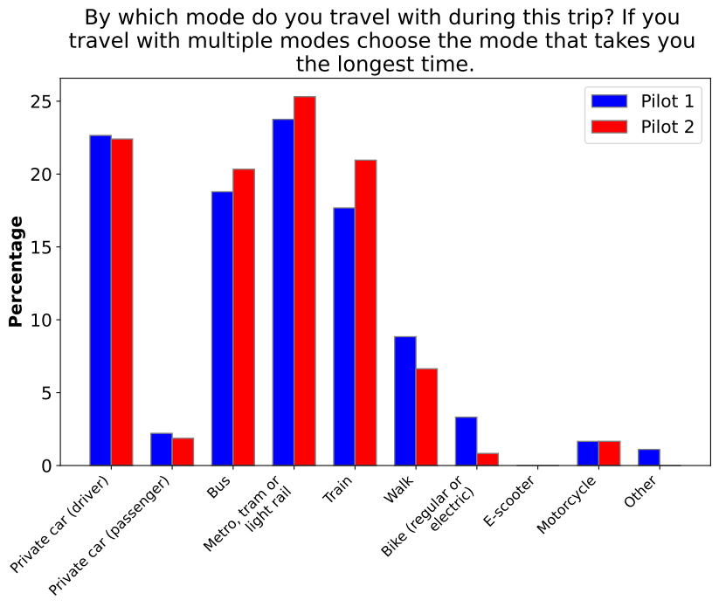
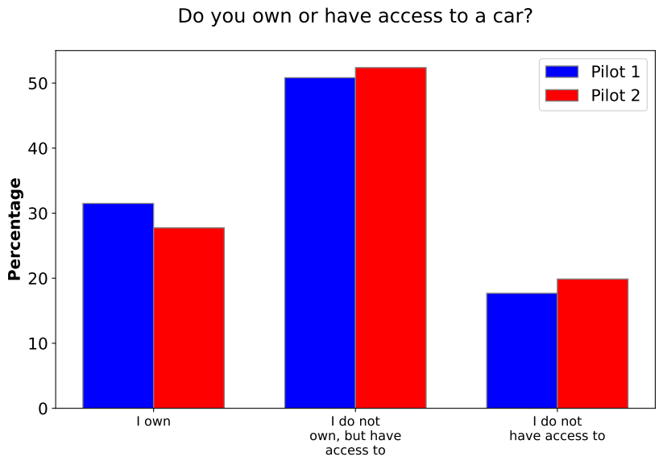
- The reported daily trip consists mainly to a trip to the workplace or the education place (40% each, in the second pilot, slightly less in the first). Other trips are directed to leisure activities, to visit family or friends, shopping, other.
- Nearly 70% of these trips are done in the morning.
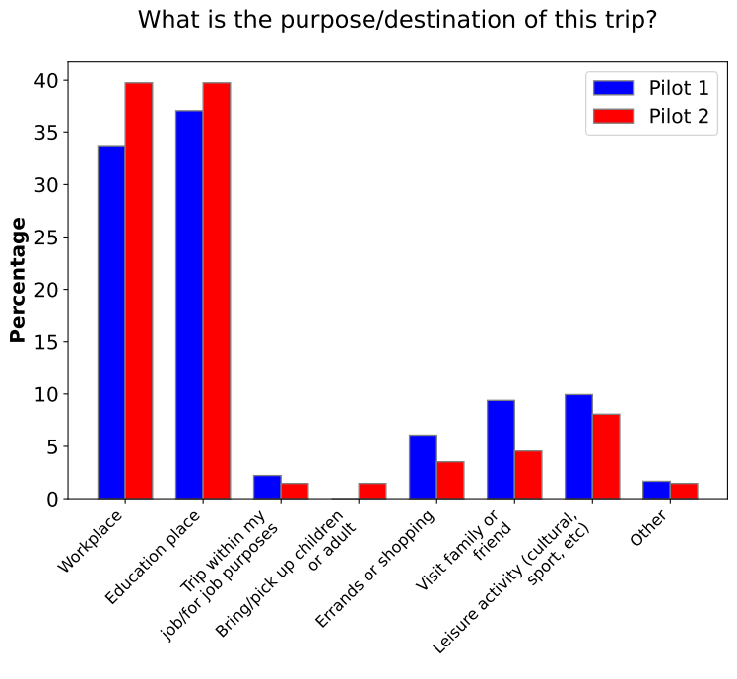
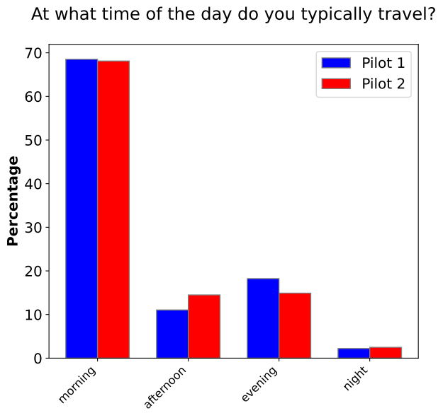
- Only around 4% in both pilots state they have no alternative transportation mode for their trip, however 50% of second pilot respondents (55% in the first) indicate that the alternative is “somewhat” or “much worse” than their usual mode.
- When respondents who use private transport are considered separately from those who use public transport, the proportion of individuals who find alternatives to their usual modes “somewhat” or “much worse” rises to approximately 75%, compared to just 45% among public transport users.
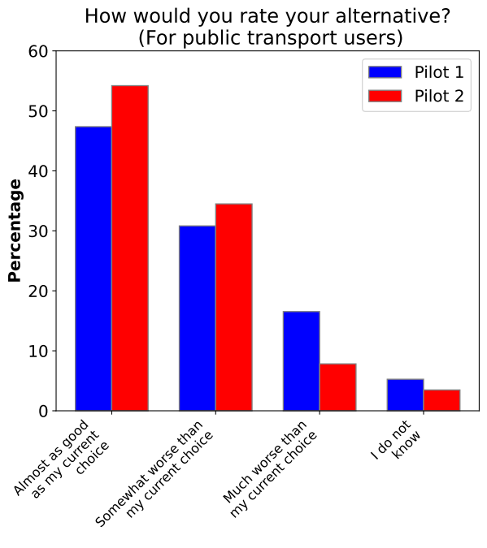
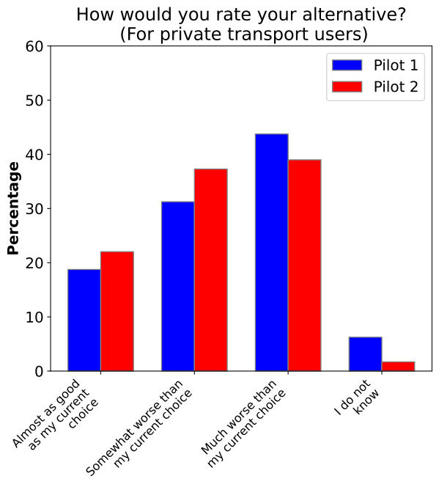
- To enter and leave the Community of Madrid there are several tolls that help to regulate traffic and avoid major traffic jams. In particular, one of these tolls may disappear in the future and drivers will no longer have to pay a toll to travel on these toll roads.
- Madrid Low Emission Zone (ZBE) in general terms consists of traffic regulations, which are permanently established in the geographical area defined by all public roads in the municipality of Madrid, prohibiting the access and circulation of all vehicles with environmental classification A in the Vehicle Register of the Directorate General of Traffic.

Results: Political views, attitudes toward inequality and trust
- There are large differences between the pilot and main survey regarding political views and attitudes.
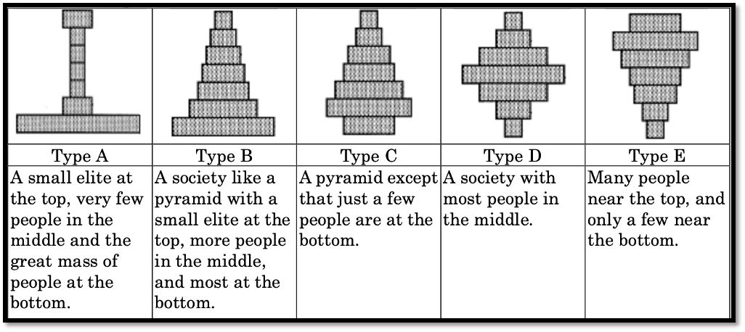
- Concerning economic inequality, most respondents think that Spain is a society where the majority of people are on the bottom of the distribution. When asked about how society should be, the vast majority wants a society where most people are in the middle or near the top.
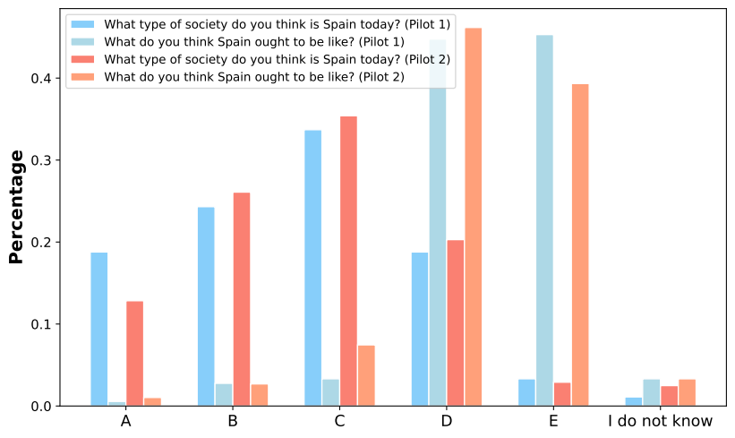
- Concerning trust in institutions, the two pilots show very similar results: survey samples tend to have relatively lower trust in politicians and political parties and higher trust in other authorities and institutions.
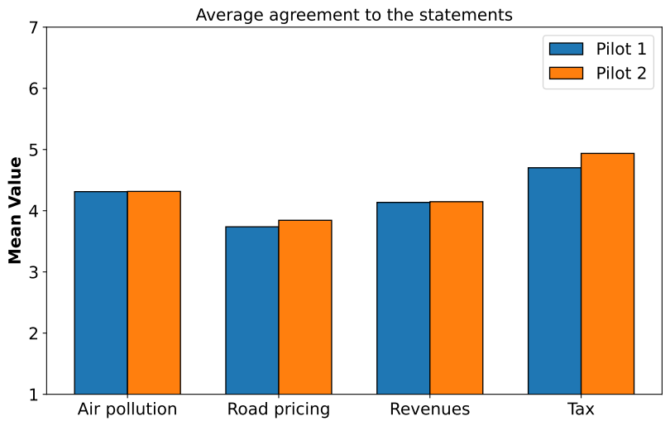

Results: Attitudes toward transport pricing policies
Attitudinal questions toward transport policies were presented in the two surveys. The main results are:
- A considerable share of respondents in the survey do not think that road pricing will reduce traffic congestion problems.
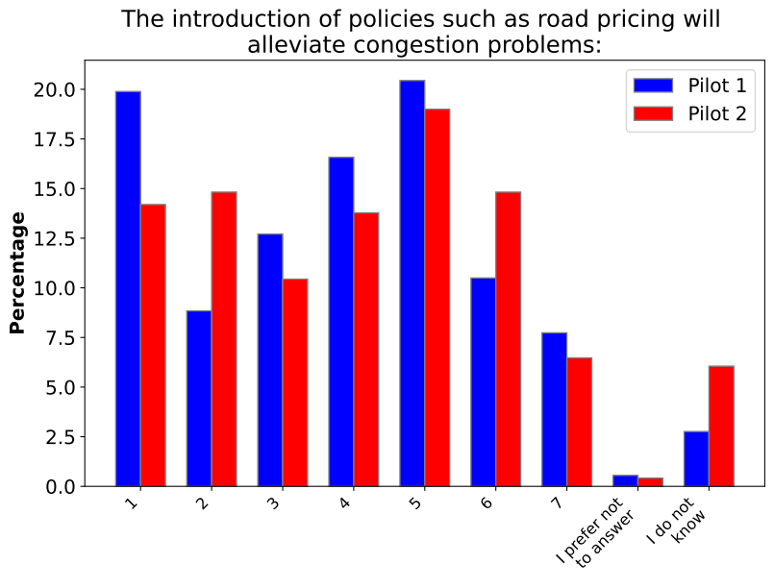
- There is great heterogeneity of agreement regarding the statement that revenues collected through taxes are used to create a well-functioning welfare state and society.
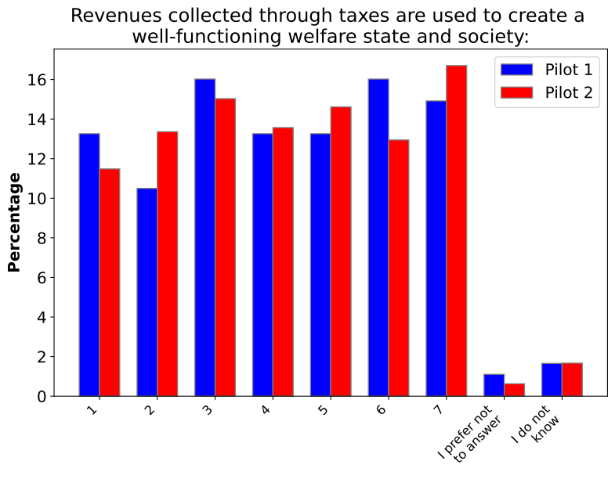
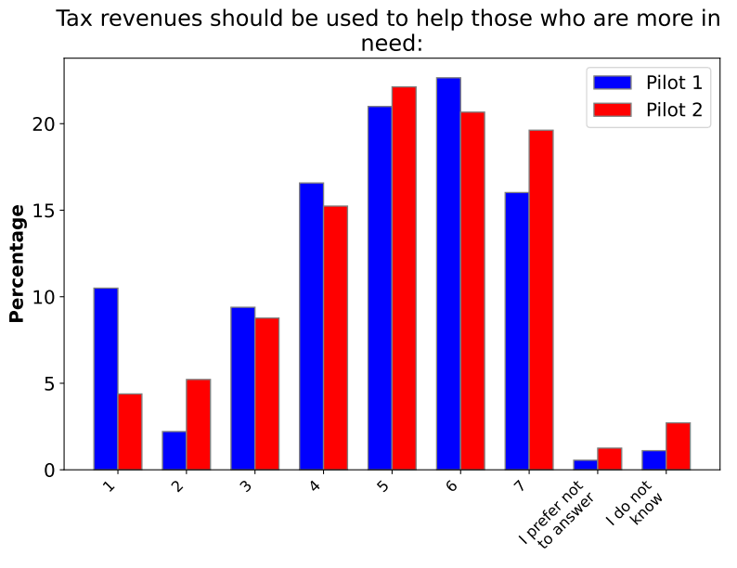
- A considerable share of respondents in the survey agree on the fact that tax revenues should be used to help those who are more in need.
- The respondents seem to be negative towards universal road pricing, and prefer options which include the lowest economical investments.
- As revenue alternative, there is general preference towards investments in public transports, walking and cycling.
- Our sample under represents those who have compulsory schooling as their highest education level.
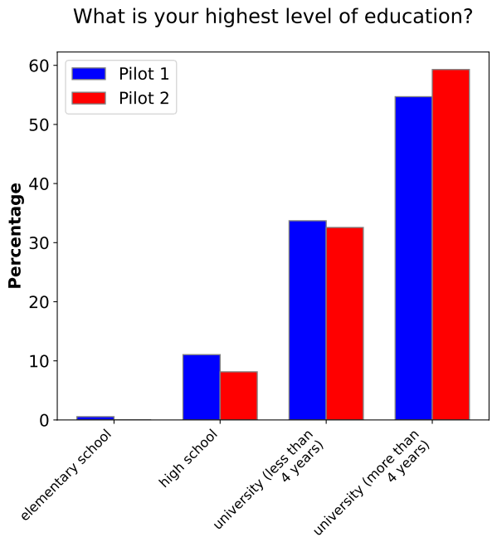
- The highest share of main survey respondents, by far, prefers that road pricing revenues are spent on investments in public transport, walking and cycling.
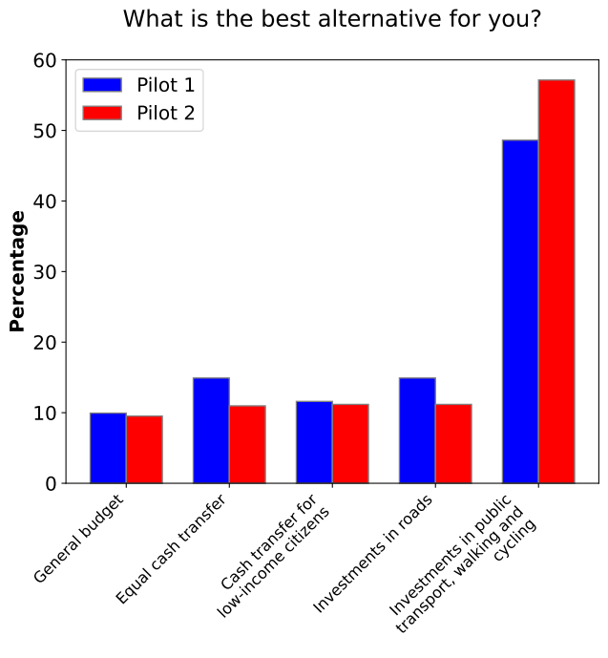
Figure S 1: Views on the road pricing proposal and the current toll system.
Conclusions
Our results suggest that opinions on road tolls and road tax reform are quite divided. Many respondents are negative towards both the current road tolls and universal road pricing, and do not expect road pricing to have positive effects. Given that the sample from the main survey has a slight over-representation of urban residents and voters for environmental parties, opposition towards these policies in the population is likely to be somewhat stronger in reality. However, there is also a large group of respondents who are neither positive nor negative towards road pricing or road tolls, or do not know what their opinion is. Moreover, respondents are slightly more positive towards road pricing than the current road tolls. This is interesting given that about half of car drivers do not pay road tolls today, while everyone would have to pay something under universal road pricing.
Attitudes towards both road pricing and road tolls vary considerably by gender, education, travel mode and political party. Among car drivers, there is no clear tendency that those who pay high road tolls today are more in favor of replacing road tolls with road pricing. However, these findings are just bivariate correlations, not causal relationships. In future work, one should look more closely into causal explanations of support for or opposition against road pricing, and what this implies for the prospects of a road tax reform being successful. Interestingly, not all drivers seem to be aware of what they pay in road tolls, which could have implications both for travel behavior and public support.
Regarding survey methodology, we note that neither sample is perfectly representative, but the main sample which was recruited using the population register is more representative than the pilot sample which was recruited through social media. Interestingly, the samples are similar in the sense that those who have higher income and education and vote in elections are overrepresented in both. On the other hand, the samples are quite different with respect to travel behavior and party support.

Introduction

Background
Road tax reform is high on the political agenda in Norway and other European countries (ITF, 2023). Some have proposed to replace existing road tolls as well as other taxes with universal road pricing where car drivers pay a tax which is differentiated geographically and by time of day (Börjesson et al., 2023). Universal road pricing differs from traditional road tolls and congestion pricing in the sense that it covers all traffic, not only in specific places or at specific times, and drivers pay a price based on distance and timing of their driving. It also differs from fuel taxes because it is geographically differentiated and applies to electric as well as conventional vehicles. In 2022, a government investigation on road tax reform was carried out in Norway. This study included universal road pricing as part of the recommendations, but political progress on implementing road pricing has stalled, indicating a need for further research (Skatteetaten & Statens vegvesen, 2022).
Little is known so far about public attitudes towards universal road pricing. Experiences from related policies like (cordon-based) congestion pricing, fuel taxes etc. show that public opposition is a challenge (Börjesson et al., 2012). Various explanations have been proposed, like self-interest (de Borger and Proost, 2012), concern for low-income groups, populist attitudes (Aasen and Sælen, 2022) or pessimistic beliefs about the effect of policies (Douenne and Fabre, 2022). Existing literature suggests that earmarking of revenues to environmental purposes can increase support (Sælen and Kallbekken, 2011; Baranzini et al, 2021), but the government also needs revenues to fund other public services. Such earmarking could also have a polarizing effect (Tatham and Peters, 2022). Baranzini et al. (2021) find that more information about the effect on traffic and local pollution can increase support for congestion pricing.
All studies mentioned above show that there is large heterogeneity in attitudes towards environmental taxes. If one wants to evaluate the prospects of a road tax reform being successful, evidence representative of the general population is desirable. This may pose challenges in terms of survey methodology, as some groups may be more likely to answer surveys about road pricing, depending on the survey and recruitment methods.

Purpose of the report
This report documents the data and results from a study on public support for universal distance-based road pricing and attitudes towards transport policies (A-planet). In 2023 and 2024, a survey on road pricing was carried out in Spain (Madrid) and Norway in several rounds. In this report, we provide detailed documentation of the data collection process and sample characteristics for the Norwegian survey. The objectives of this report are to
- Document the survey design and data collection
- Describe the samples in terms of socio-demographic characteristics
- Show descriptive results regarding location of the trip, travel behavior and road toll costs (self-reported and calculated)
- Show descriptive results on attitudes towards road pricing and road tolls as well as other political views
- Evaluate the representativeness of the samples and discuss implications for survey methodology
The Norwegian survey consists of two rounds of data collection where both the recruitment process and sample characteristics vary between versions. The two waves of recruitment used different approaches: first, we recruited a convenient sample using social media for a pilot, then we recruited a representative sample of the Norwegian population using population registries at the Norwegian tax administration for the main survey. The questionnaires consist of multiple parts, including socio-demographic questions, a simplified travel survey, political views, attitudes toward inequality and transport policies. A few questions were adjusted between pilot and main survey so the two questionnaire are slightly different.
Since we have a considerable sample size in the pilot survey, and because there could be benefits from combining different data collection strategies, we present results from both surveys. However, as the sample in the main survey appears to be more representative, we put more weight on this when discussing our findings.

Limitations
Universal road pricing is a policy that has not been introduced yet in Norway or any other country, apart from Singapore, which is a city-state covering a much smaller and more homogenous geographic area. One should be aware that the results in terms of attitudes could be specific to the current context, and that attitudes could change in the future if the topic receives more public attention or if once the policy is eventually tested or implemented. In our survey we attempt to test the effect of giving more information, but the results of this might not be representative of the effect of information in a more real-life setting.

Structure of the Report
Section 2 describes the survey design, followed by an overview of the data collection methods in Section 3. Section 4 shows the results in terms of basic sample characteristics (4.1), geography and travel behavior (4.2) and attitudes (4.3) Lastly, Section 5 discusses and concludes.

Survey design

Structure of the questionnaire
The questionnaire consists of the following parts:
- Introductory questions about place of residence and car ownership
- A simplified travel survey about a typical daily trip
- Questions about perception of and attitudes towards economic inequality
- Introduction to road pricing and stated choice experiment with different road pricing policies
- Questions about political views and attitudes towards transport policies
- Questions about socio-demographic characteristics
The full questionnaire is shown in Exhibit 1 in the Appendix.

Geography and travel behavior
In the Norwegian versions of the questionnaire, respondents are first asked to select their region (county) of residence. They are then asked to locate their home on a map which is centered on this region. After questions about car and bike ownership, respondents are then asked to think about a trip of at least 10 minutes that they make daily or regularly from their home to another destination. They are then asked to locate the destination on the map and answer questions about travel mode and characteristics of the trip.
The origin and destination GPS coordinates are used to calculate the road toll costs on the fastest route using the road toll calculator from Fremtind Service. In the pilot survey, respondents are asked about their total trip cost, including fuel, tolls, parking, or public transport price. Conversely, in the main survey, respondents are only asked what they pay in road tolls, such that self-reported and calculated road tolls can be compared.

Choice experiment
Both surveys included a choice experiment designed to study support for road pricing similarly to that of Baranzini et al. (2021), who study support for congestion pricing in Geneva. In the choice experiment respondents were asked to choose several times between two types of road pricing, were price levels and other tax characteristics changed, or the current system with road tolls. We do not present the results of this experiment in this report.

Attitudinal questions
The surveys also contained a section with attitudinal questions, including:
- The questions about perception of and attitudes towards economic inequality (part (c) in Section 2.1)
- A question about how people would like the revenues from road pricing to be spent, which was included in the introduction to the choice experiment (part (d) in Section 2.1)
- The questions about political views and attitudes towards transport policies (part (e) in Section 2.1)
The questions mentioned under (1.) and (2.) were included in all versions of the questionnaire. The questions mentioned under (3.) were revised and differ between the pilot survey and the final survey in Norway.
In (1.), the questions about economic inequality, respondents were asked how the distribution of economic resources in their country is and how it should be, choosing between options with different illustrations of inequality. The first question is shown in Figure Survey design.1 below, with illustrations. The same illustrations were used in both questions. After this, respondents received a third question asking how fair or unfair they think the current distribution of wealth in their country.

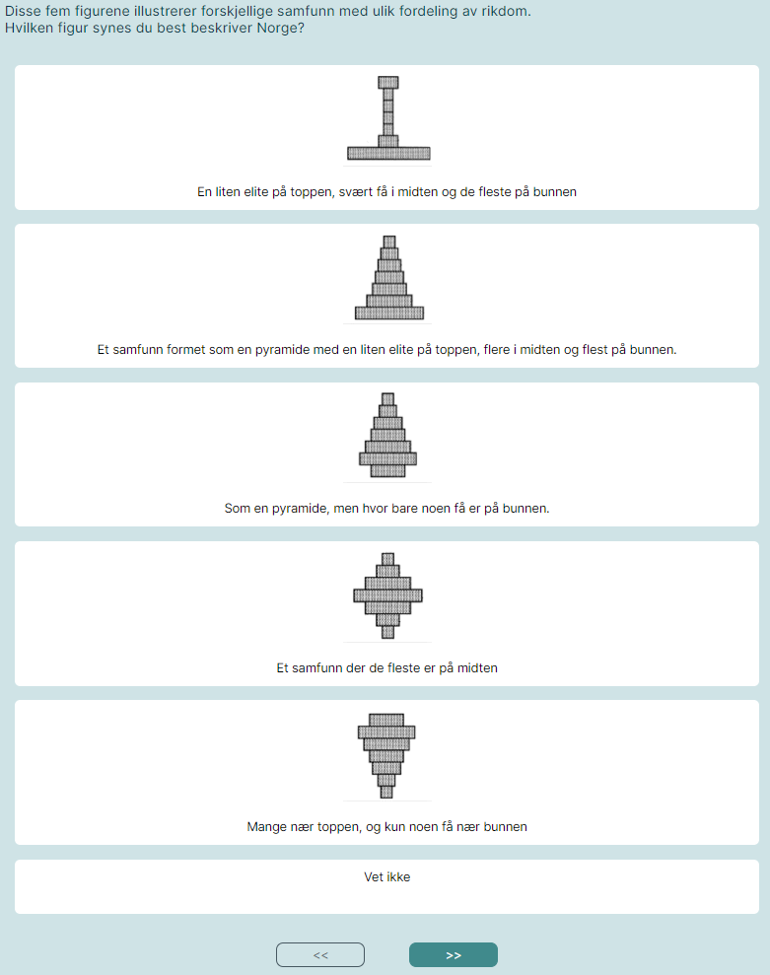
Figure .1: How the question about perception of economic inequality appeared in the survey.
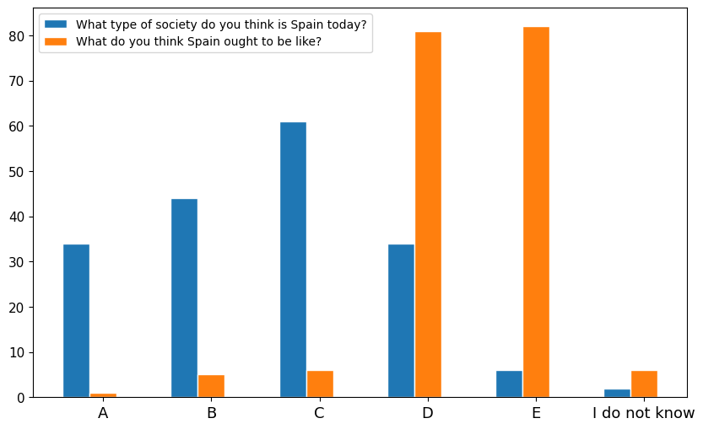
Related to the questions under (3.), in both surveys, respondents are asked about which party they voted for in the previous election (i.e. 2023) and trust in various public and political institutions, though the list of institutions varied between surveys.
In the pilot survey, respondents are asked about the following questions related to transport policies (3.):
- Rate how road pricing (implemented as a distance-based fee), would affect both themselves and low-income residents, indicating whether each group would be better or worse off
- General attitudes towards air pollution, road pricing, public revenues, taxation, and road tolls
In the main survey, respondents are more specifically asked the following questions about attitudes towards transport policies (3.):
- Whether they think air pollution is a serious environmental and health problem
- Whether they think road pricing will reduce greenhouse gas emissions, congestion, air pollution and personal car use
- Which groups will gain or lose from road pricing
- General attitudes towards (i) current road tolls and (ii) the proposed road pricing scheme
- Three final questions about attitudes towards public revenues, taxation and privacy

Sociodemographic characteristics
In the questionnaire, respondents were asked about to report the following characteristics (in addition to where they live):
- Year of birth
- Gender
- Education level
- Gross personal income
- The number of adults in the household (main survey)
- The number of people in the household (pilot survey)
- The number of children under 15 in the household
- Main occupation (working, studying etc.)
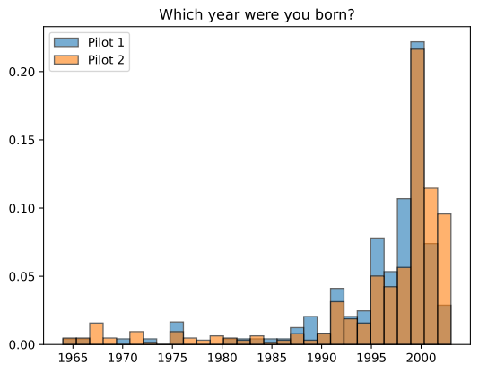

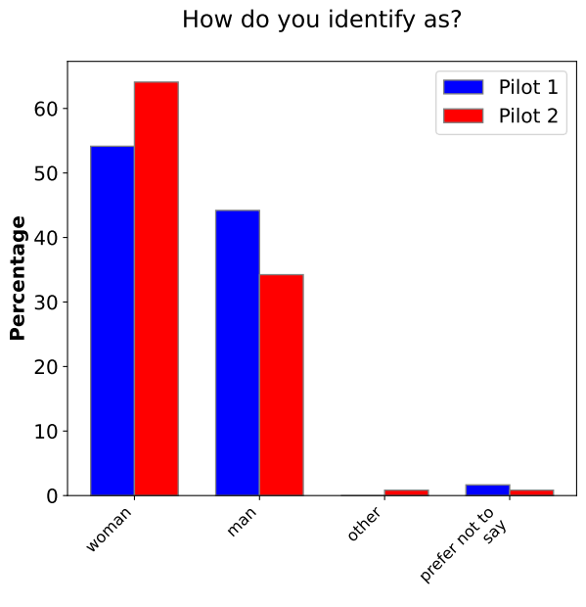
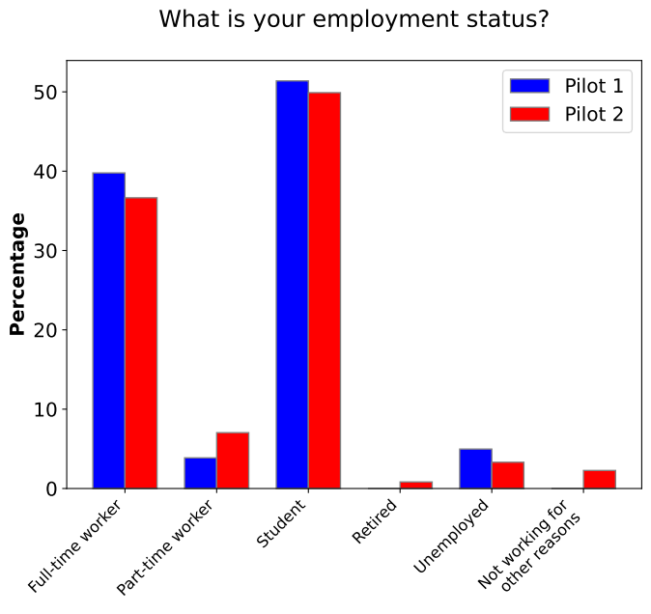
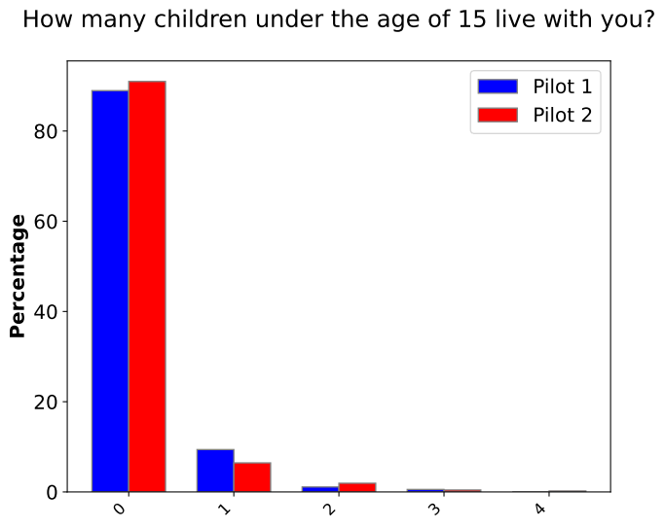
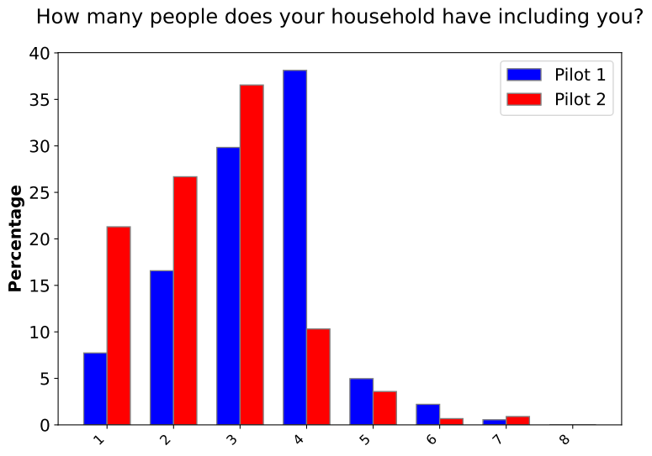

Data collection
The pilot survey was launched in September 2023, while the main survey was run in March 2024. The recruitment method varies, as explained below. In both surveys, respondent were incentivized in terms of a lottery where they could win a gift card of value about NOK 5000.

Pilot survey in Norway
To recruit respondents for the pilot survey, a sponsored Facebook post was created, see Figure Data collection .2. The post and corresponding survey were launched on September 27, 2023 and people could answer until the 4th of October. To expand the reach of the survey, researchers at TØI asked several organizations to share the Facebook post on their Facebook pages. The only organization that confirmed that it had shared the post was Syklistforeningen (the Cyclists’ Association). The pilot survey received 1,741 responses.
The Facebook post text stated:
“What do you think about replacing current road tolls with other forms of taxes? Researchers at TØI wish to study people’s attitudes toward tax schemes that can replace road tolls. We want your feedback!”
In addition to survey responses, the Facebook post received considerable attention on social media. About 1,500 users reacted to the post with an emoji, of which about 2/3 posted an angry face. About 1,200 users commented on the post. Many of the comments also expressed negative attitudes towards road taxes.
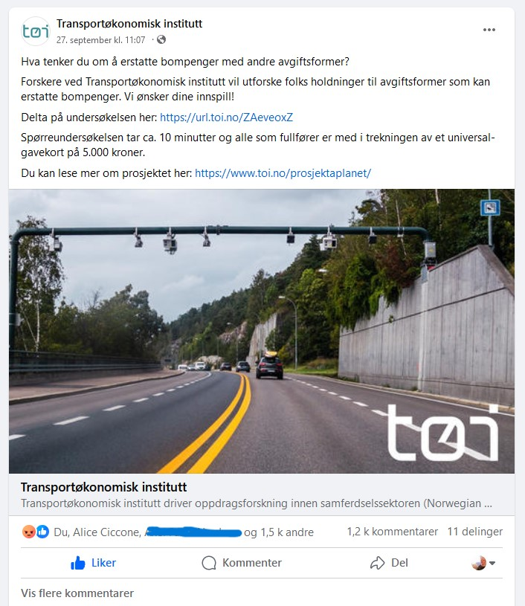
Figure .2: The Facebook post with the link to the survey (text in Norwegian).

Main survey in Norway
To recruit respondents for the main survey, The Norwegian Tax Administration drew a representative random sample of roughly 50,000 people from the population register. These were contacted by e-mail using contact info from the Directorate of Digitalization (Kontaktregisteret). The survey was launched on Friday, March 8, 2024, and the sample was invited in several waves until the 12th of March. Those who had not answered the survey received a reminder the 15th of March and had the possibility to answer the survey until the 21st of March. The main survey received 3,910 responses.
The e-mail invitation stated:
“The Institute of Transport Economics (TØI) invites you to take part in a survey about how people in Norway travel, and what they think about future transport solutions. It takes approx. 10 minutes to answer.
The survey is an important part of a research project funded by the Research Council. The results will provide the authorities with new knowledge that may have an impact on future transport and tax policy. By sharing your opinions, you contribute to research that can be used to create a more efficient, fair and sustainable transport system.”

Data cleaning and filtering
The data cleaning process included removing respondents in the survey who indicated they had no regular trip of at least ten minutes (regardless of travel mode). When respondents were later asked about the length of their daily trip, they were allowed to select an option indicating their trip was less than ten minutes long. Despite the slight inconsistency, these respondents were not filtered out. The sample was also filtered to exclude participants with very short response times of less than six minutes, roughly corresponding to responses falling below the 2nd percentile of response times. As a result, 22 responses from the pilot survey and 71 responses from the main survey were excluded. The final sample included 3,839 respondents for the main survey in Norway and 1,719 respondents for the pilot survey in Norway.

Results
In this chapter, we describe our data and present selected results in terms of socio-demographic characteristics (4.1), geography and travel behavior (4.2) and attitudes (4.3). Since we have a considerable sample size in the pilot, and because there could be benefits from combining different data collection strategies, we present results from both surveys. However, as the sample in the main survey appears to be more representative, we put more weight on this when discussing our findings.

Basic sample characteristics
Table Results.1 provides the sociodemographic statistics for the two surveys in Norway compared with the national average, based on official statistics from Statistics Norway (SSB). It is interesting to compare the pilot survey and the main survey to the national average and between each other, considering their distinct recruitment methods.
Table .1: Sociodemographic statistics: shares and averages for Norwegian pilot and main surveys.
Variable | Pilot survey mean or share (N = 181) | Main survey mean or share (N = 414) | National average
Age (years) | 54 | 48 | 49
Female share | 12% | 45% | 50%
Number of adults per household, including respondent | 2.01 | 2.01 | 2.11
Number of children per household
No children | 69.5% | 64.5% | 56.5%
One child | 13.6% | 14.8% | 15.2%
Two children | 13.0% | 15.3% | 19.2%
Three or more children | 3.9% | 5.4% | 9.1%
Highest completed education
Basic school level | 3.0% | 2.8% | 23.7%
Upper secondary education | 22.6% | 24.5% | 39.5%
College/university (4 years or less) | 36.0% | 38.1% | 25.3%
College/university (5 years or more) | 35.4% | 32.1% | 11.6%
Don't want to state | 3.1% | 2.3% | Not Applicable
Employment Status
Employed | 75.5% | 73.6% | 62.4%
Student | 1.3% | 8.0% | 6.0%
Retired | 14.9% | 9.0% | 17.9%
Unemployed | 0.5% | 1.9% | 0.8%
Other | 5.4% | 5.6% | 12.9%*
Don’t want to state | 2.4% | 1.9% | Not Applicable
Income
Annual Gross Income | NOK 792 558 | NOK 702 065 | NOK 561 700
*Including participants in labor marked measures and recipients of work assessment allowance/disability benefits
Source: Statistics Norway (SSB)
The sociodemographic statistics indicate that both pilot and main surveys have been answered by more men, people that have fewer children and higher education and income. They also have a higher share of employed respondents at the expense of retired people and the “Other” category. Nevertheless, the pilot survey has a much higher rate (14.9%) of retired people compared to the main survey (9.0%), although lower than the national average (17.9%).
Probably the most important difference is the much lower female share in the pilot compared both to the main survey and to the national average, with a female share of 12% compared to the national average of 50%. In addition, the average age of the respondents in the pilot survey is higher than the national average. Conversely, respondents of the main survey better match the national average for the female share, 45% compared to 50%. The main survey respondents are also slightly younger than the national average.
Figure Results.3 shows the home counties distribution for the pilot survey respondents, for which Oslo and Viken are slightly overrepresented compared to the national average. Similarly, Figure Results.4 shows the distributions of the home counties of the main survey respondents and the national average are within 2%-points, except for Oslo which has a share 5%-points greater than the national average. Both pilot and main survey respondents live in more urban areas compared to the national average.

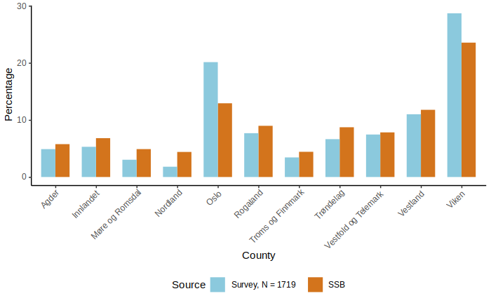
Figure .3: Share of home counties for pilot survey (2023 counties), compared to Statistics Norway (SSB).

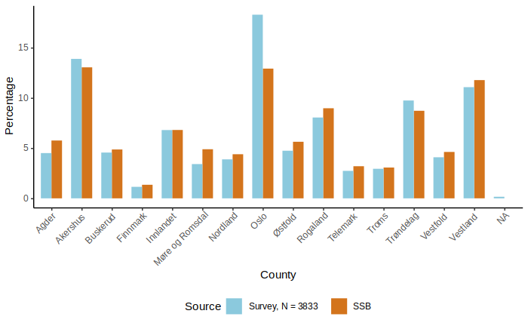
Figure .4: Share of home counties for main survey (2024 counties), with comparison to Statistics Norway (SSB).
Figure Results.5 provides details on the income distribution of the pilot and main survey respondents, illustrating that the sample is skewed towards higher income categories. According to Statistics Norway (SSB), average gross personal income was 561,700 in 2022.
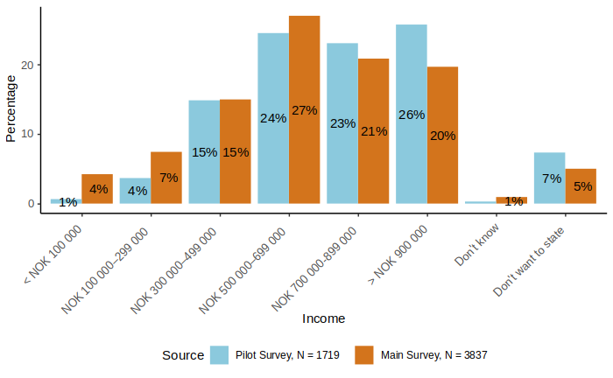
Figure .5: Share of annual income categories for the pilot and main surveys.
To sum up, the main survey better matches the national averages and thus is more representative for the country of Norway. Both surveys over-represented people with high income and education and residents of Oslo and the surrounding region, but the share of high-income earners is more extreme in the pilot survey. The pilot survey also has a vast majority of male respondents. Nonetheless, survey responses from the pilot survey are still valuable. As we will see in later chapters, there are some interesting differences between the two samples with respect to other variables.

Geography and travel behavior

Car and bike ownership and access
Table Results.2 shows the summary statistics for car and bike ownership and access for the Norwegian surveys.
Table .2: Summary statistics for car and bike ownership and access in the Norwegian surveys.
Variable | Pilot survey share  (N = 1,719) | Main survey share  (N = 3,839) | National average
Car ownership
Owns a car | 91.6% | 74.9%
Has access to car | 6.6% | 14.1%
Does not have access to a car | 1.8% | 10.9%
Household car ownership/access*
Owns or has access to a car | 72.2% | 59.1% | 68.3%¹
Bike ownership
Owns a bike | 74.2% | 71.7%
Has access to a bike | 4.6% | 7.3%
Does not have access to a bike | 21.2% | 20.9%
* Here, respondents who belong to a single-adult household are weighted twice as much as those belonging to a two-adult household, such that the number represents the average across households.
¹ Source: Fevang, E., Figenbaum, E., Fridstrøm, L., Halse, A. H., Hauge, K. E., Johansen, B. G., & Raaum, O. (2021). Who goes electric? The anatomy of electric car ownership in Norway. Transportation Research Part D: Transport and Environment, 92, 102727.
Most of the pilot survey respondents (91.6%) own a car, compared to 74.9% of the main survey respondents. The main survey sample has lower household car ownership and access compared to the national average, while the pilot survey sample is higher and closer to the national average.
Respondents were asked about their plans to purchase a car within the next 12 months. The question allowed respondents to select multiple options from the following choices: "Yes, petrol car", "Yes, diesel car", "Yes, hybrid or plug-in hybrid car", "Yes, electric car", or exclusively: “No”.
Most responders (about 70%) in both surveys are not planning to buy a car. Among those who responded, 65 indicated they planned to purchase more than one type of car (e.g., both a petrol car and a diesel car). Among those who responded, 124 indicated they planned to purchase more than one type of car.
Among those who state that they plan to purchase a car, 41% of the main survey respondents (and 33% of the pilot) state that they will buy an electric car (plug-in hybrids not included). Given that purchasing a car could mean purchasing either a new car or a used car, this is a reasonable share. We do not know whether the respondents plan to buy a new or used car. See Error: Reference source not found and Error: Reference source not found in the Appendix for more details on which cars respondents plan to buy.

Trip origins and destinations
According to the spatial data provided by the respondents, there were 295 unique municipality origins and 283 unique municipality destinations for the main survey. A location was considered Urban if the provided coordinate was located in one of the following municipalities: Sarpsborg, Fredrikstad, Bærum, Lillestrøm, Nordre Follo, Lørenskog, Oslo, Drammen, Porsgrunn, Skien, Kristiansand, Stavanger, Sandnes, Bergen, and Trondheim. All other locations were considered Rural. This distinction is based on the list of the largest urban settlements published by Statistics Norway. This rough classification is motivated by the road pricing scheme presented in the survey, which has different prices for urban and rural areas. For simplicity, we do not distinguish between different neighorhoods within municipalities.
The three most common municipalities for origins and destinations in both surveys were Oslo, Bergen, and Trondheim. Figure Results.6 shows maps of the origins and destinations for each trip, for the main survey. We can observe coverage extending across the country.
Similar findings yield for the pilot survey. Although the main survey captures responses from more municipalities compared to the pilot survey (the trip origins and destinations represented 201 and 193 unique municipalities for the pilot survey, respectively). Equivalent maps are included in the Appendix, as seen in Error: Reference source not found.

A: Origins | B: Destinations
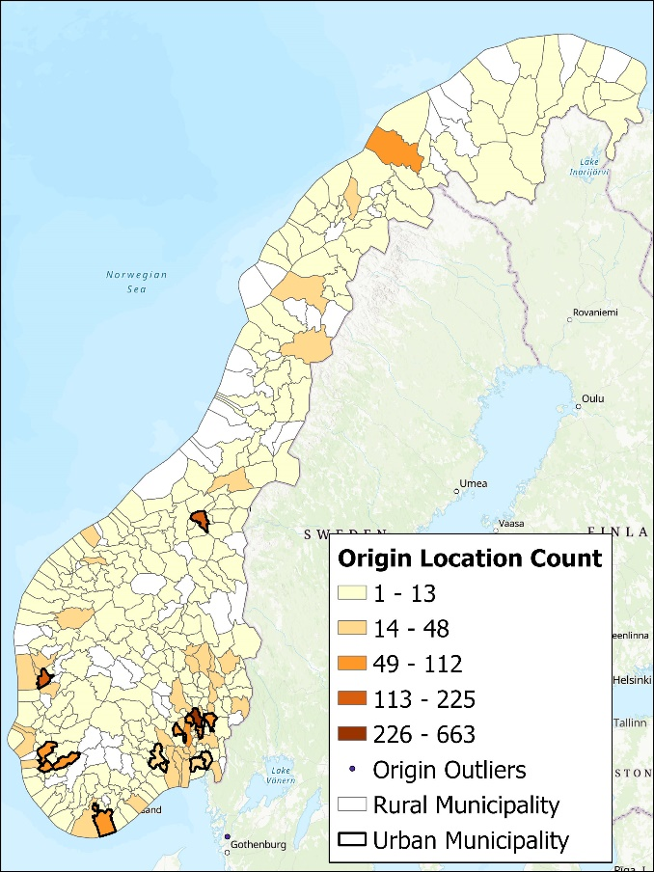 | 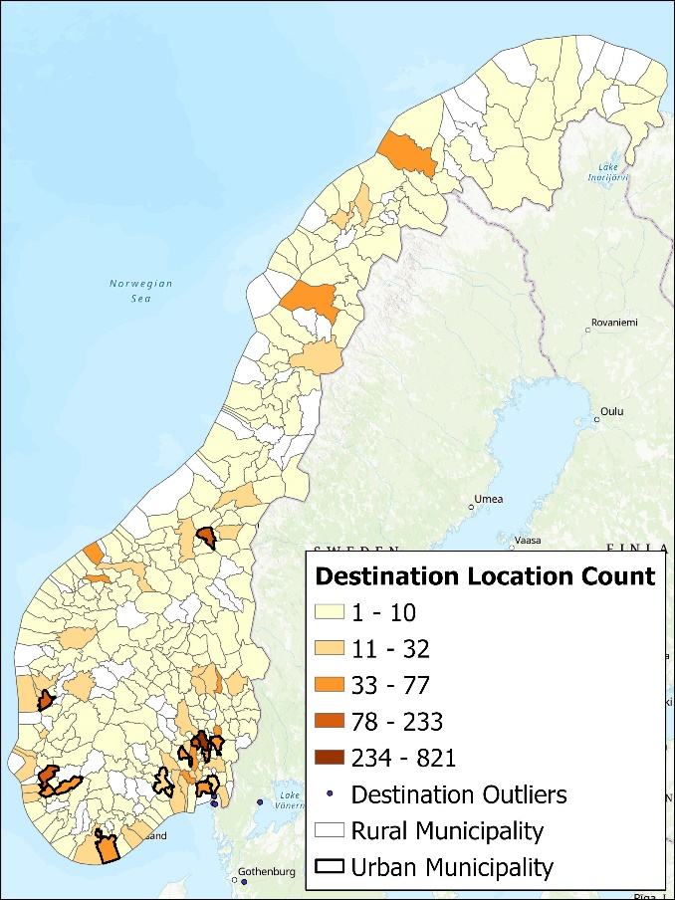
Figure .6: Shaded (choropleth) maps of the origins and destinations of trips for the main survey. Urban municipalities are outlined in bold.
Figure Results.7 presents the mapping of origin and destination types for each respondent for the main survey. The figures show that most trips are “Urban to Urban” or “Rural to Rural” for each survey. As expected, more trips are “Rural to Urban” than the other way around. These trip characteristics are observed in the pilot survey as well. See Error: Reference source not found in the Appendix for a similar diagram for the pilot survey.
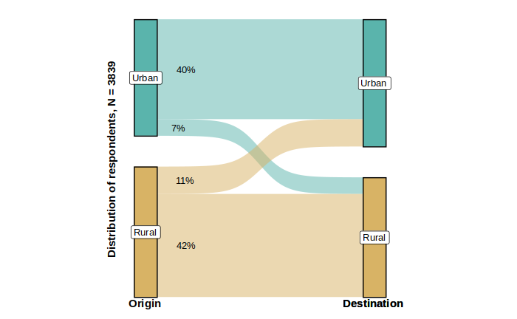
Figure .7: Mapping of individual’s origin and destination types for the main survey.

Trip characteristics and mode choice
Figure Results.8 provides the share of trip purposes for all trips for the pilot survey and main survey. In both surveys, “Travel to workplace” is the most common trip purpose. The share of school trips is very small in the pilot survey, especially compared to the main survey.
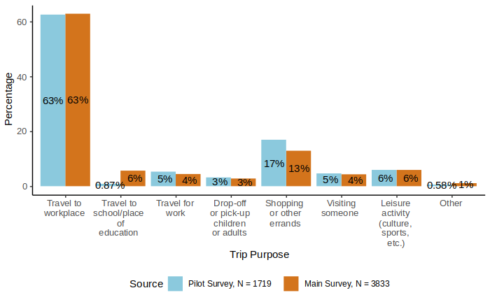
Figure .8: Share of trip purpose for all trips in the pilot and main surveys.
Figure Results.9 illustrate the share of travel modes for all trips in the pilot and main surveys. In both surveys, more than half of the trips use the 'Private car (driver)' mode. The second most common mode is “Bike” at 10% in the pilot survey and “Bus” at 13% in the main survey.
Figure Results.10 and Figure Results.11 show the distribution of travel modes by gender for the pilot and main surveys, respectively. As expected, there are some gender differences, with a higher share of car drivers among men in both surveys. Since men are highly overrepresented in the pilot survey, this means that the modal split is more similar when we account for this. Still, there is a lower share of car drivers in the main survey than in the pilot survey also within each gender.

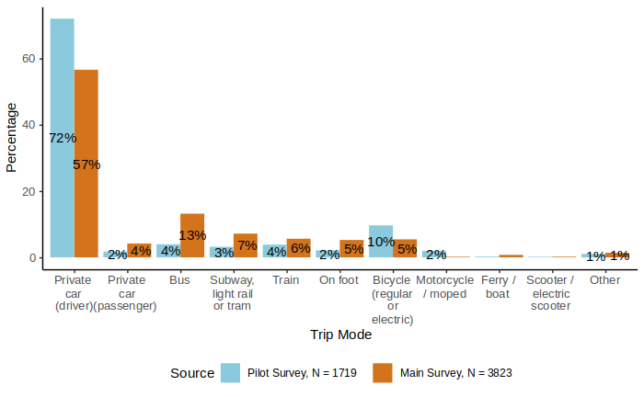
Figure .9: Share of travel mode for all trips in the pilot and main surveys.
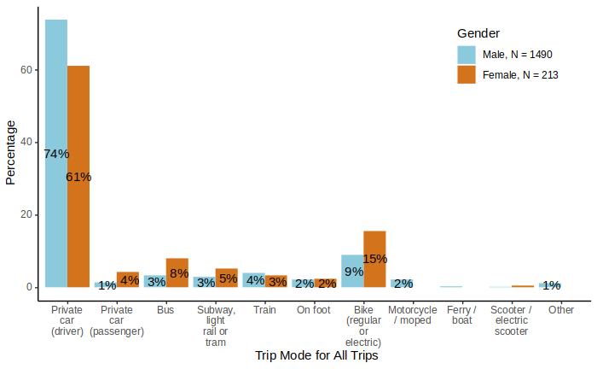
Figure .10: Share of travel mode for all trips by gender, in the pilot survey.

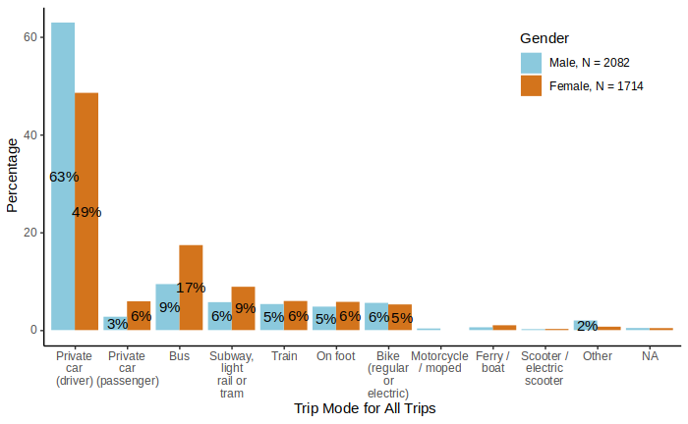
Figure .11: Share of travel mode for all trips by gender, in the main survey.
Figure Results.12 compares the share of travel modes for work trips between the pilot survey and main survey to the National Travel Survey (2023). Public transport includes bus, subway, light rail or tram, and ferry/boat. In the pilot survey, private car (driver) and bike modes are overrepresented, while walking is underrepresented. Furthermore, in the main survey, most of the modes are within 2%-points of each other, except for public transport which is overrepresented in the main survey, and the walking mode which is underrepresented. This could be related to the fact that respondents were not asked to report all trips – only one typical trip, and that this was required to have at least 10 minutes travel time.
There are some notable differences between the two samples. Those who drive to work, and also those who cycle, are overrepresented in the pilot survey, but not in the main survey.

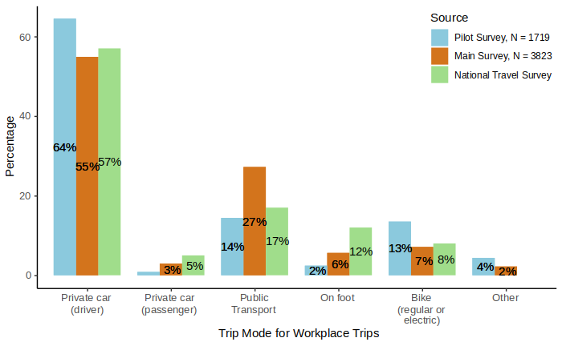
Figure .12: Share of travel modes for workplace trips in the pilot survey and main survey, with comparison to the National Travel Survey (2023).
Figure Results.13 illustrates respondents’ usual trip mode and corresponding alternative mode, as well as their rating of the alternative relative to their usual mode trips for the main survey. Here, the car category includes private cars (as driver or passenger) and motorcycles/mopeds. Light transport includes walking, bicycles, e-scooters, and other modes.
The most common alternative mode among car users is public transport. However, many car users substitute with a different car-based mode. This includes car drivers whose alternative mode is being a car passenger. Among public transport users, there is a close to even split between those who substitute with car, a different public transport mode and light transport.
Those who substitute with public transport tend to rate the alternative as worse than their usual mode which may be due to longer travel times with public transport. See Error: Reference source not found in the Appendix for an equivalent diagram for the pilot survey.

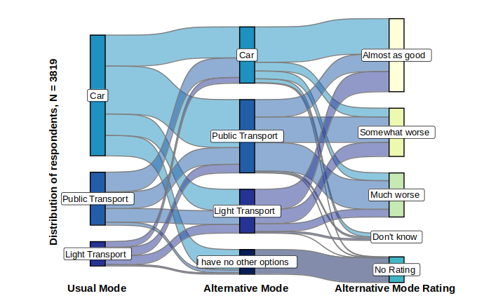
Figure .13: Mapping of main survey individuals’ alternative trip mode, and alternative mode rating relative to their usual mode for all trips. The car category includes private cars and motorcycles/mopeds. Public transport includes bus, subway, light rail or tram, and ferry/boat. Light transport includes walking, bicycles, e-scooters, and other modes.
Table Results.3 provides the percentages for each category. Notably, in the pilot survey, 18% of respondents report having no alternative transportation option. Among car users who do have an alternative, 53% indicate the alternative option is “somewhat worse” or “much worse” than their usual mode. In the main survey, 13% of respondents lack an alternative transportation option. Of the car mode users with an alternative, 63% consider the alternative option “somewhat worse” or “much worse” than their usual mode.
Table .3. Percentage of respondents’ usual trip mode, alternative trip mode, and alternative mode rating for the pilot and main surveys.
Category | Subcategory | Percentage
Category | Subcategory | Pilot Survey | Main Survey
Usual Mode | Car | 76% | 61%
Usual Mode | Public Transport | 11% | 27%
Usual Mode | Light Transport | 13% | 12%
Alternative Mode | Car | 31% | 28%
Alternative Mode | Public Transport | 35% | 37%
Alternative Mode | Light Transport | 16% | 22%
Alternative Mode | I have no other options | 18% | 13%
Rating | Almost as good | 28% | 37%
Rating | Somewhat worse | 23% | 24%
Rating | Much worse | 29% | 22%
Rating | Don’t know | 2% | 4%
Rating | No Rating | 18% | 13%
See Error: Reference source not found, Error: Reference source not found, Error: Reference source not found, and Error: Reference source not found, in the Appendix for detailed results on total trip cost, duration, time of day, and traffic conditions for the pilot survey. In addition, see Error: Reference source not found in the Appendix for results on trip length for the main survey.
Figure Results.14 shows the share of the time of day that trip is typically taken in the main survey. Respondents were not asked to report the exact departure or arrival time, only what time of day the trip took place and whether it was during rush hour. It makes sense that morning trips are most prevalent considering that we explicitly asked them to think of a trip daily trip starting from home and the most frequent type of trip was to the workplace.
Figure Results.15 depicts the share of observed traffic conditions (degree of congestion) during the trip in the main survey. For car travelers, this will be the traffic conditions that they experience themselves, while for other travelers, it could also be the conditions that they observe in the car lane of the road. Roughly half of the trips encounter little to no queuing and less than 10% of trips encounter lots of queueing. The shares as similar in the pilot survey. (See Error: Reference source not found in the Appendix).
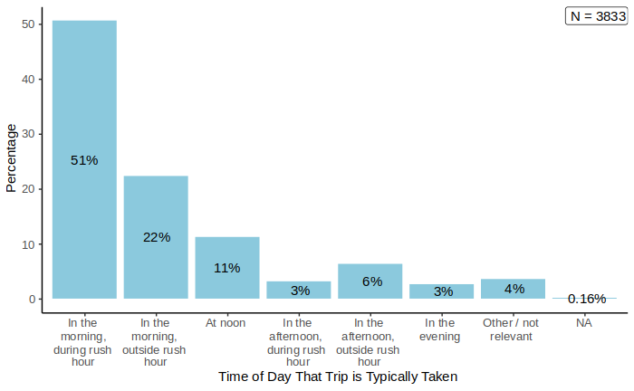
Figure .14: Share of the time of day that trip is typically taken for all trips in the main survey.
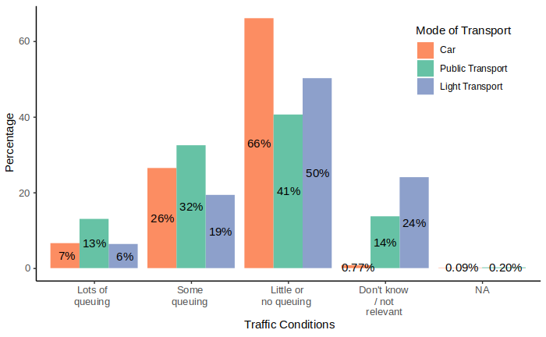
Figure .15: Share of observed traffic conditions during trip for all trips in the main survey.

Road tolls
In the pilot survey, respondents’ road tolls were calculated based on the reported origin and the destination using the road toll calculator from Fremtind Service. Almost half of the sample (49%) do not pay road tolls. This could be either because there are no road tolls on their route, or they travel with other transport modes. See Error: Reference source not found and Error: Reference source not found in the Appendix.
In the main survey, people who responded that they used a private car during their trip were asked follow-up questions about whether they paid road tolls and if so, how much. Of the 2,324 respondents who used a private car, 966 (42%) indicated they paid road tolls during their trip. Figure Results.16 shows the distribution of how much respondents think they pay in tolls for the trip and the calculated tolls for the trip based on the trip coordinates. The calculated road tolls in the main survey follow a similar distribution to those in the pilot survey, with the largest proportion being no tolls, followed by tolls between NOK 21-40. The main survey respondents reported fewer tolls between NOK 1-10 and more tolls between NOK 21-40, compared to the toll calculator.
To better understand the geographic distribution of toll payers, we examined the share of pilot and main survey respondents who pay road tolls, categorized by county. See Error: Reference source not found and Error: Reference source not found in the Appendix. For both surveys, the county of Oslo contains the highest share of those who pay tolls. In the main survey, the counties with the greatest difference between the reported and calculated percentages are Østfold, Oslo, and Rogaland. Although the compared percentages are not equal for each county, this may be due to the respondents using an alternative route than the one used by the toll calculator, rather than inaccurate reporting. However, the share of reported tolls is surprisingly much larger than the calculated tolls for Østfold (about 50 versus 15 percent). This may be due to the toll cordon that opened around the city of Sarpsborg on March 20, 2024. While only 7% answered the survey after March 20, it is possible people thought that the toll cordon opened earlier and reported tolls accordingly.

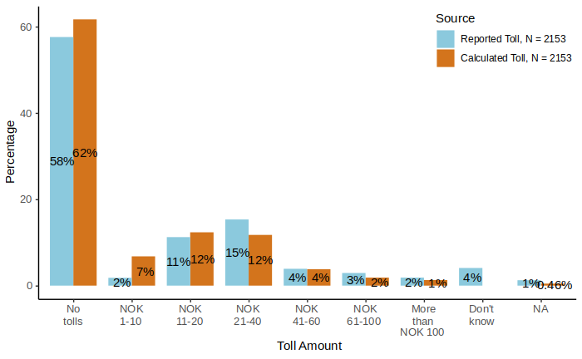
Figure .16: Share of main survey respondents’ self-reported toll costs compared to calculated toll costs.
There is considerable variation between the reported and calculated tolls. Figure Results.17 describes the consistency between self-reported toll costs and calculated toll costs. We define self-reported and calculated toll costs as consistent if calculated toll costs are within the interval that the respondent reported (e.g., NOK 21-40), and inconsistent otherwise. When considering all tolls, over half (66%) of the respondents reported paying a toll consistent with the toll calculator, while 21% reported paying more than the toll calculator.
Note that the level of consistency is ‘inflated’ by the number of respondents who correctly report zero tolls. Many of these could be traveling in areas where there are no toll gates at all, and therefore have little difficulty reporting correctly, After filtering out those with calculated tolls equal to zero, the share of those reporting more than the toll calculator increases to 37%. See Error: Reference source not found in the Appendix for a detailed sankey diagram comparing calculated and reported tolls.
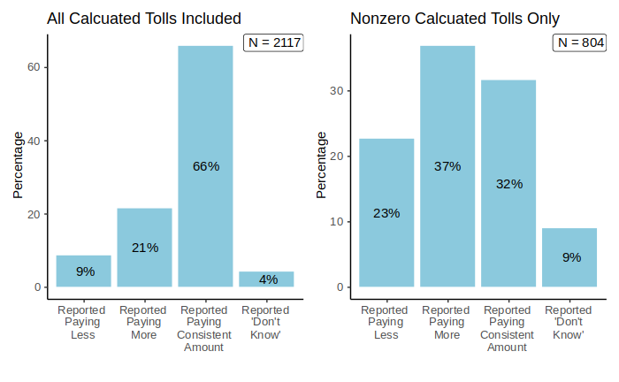
Figure .17: Share of consistency in main survey self-reported toll costs compared to calculated toll costs.

Attitudinal questions

Party preferences
To capture party affiliation, respondents were asked what they voted in the most recent election, which is the local election in 2023. Figure Results.18 shows there are respondents from all the major political parties for the pilot survey and the main survey, as well as a joint category for other parties. Figure Results.18 shows that for the pilot survey, party affiliations deviates from the national voting data shares for 2023. The largest differences are observed in the underrepresentation of the Labour Party and the overrepresentation of the Industry and Business Party. In contrast, for the main survey, nearly all the shares are within 3%-points of national voting data shares. In both the pilot and main surveys, non-voters are highly underrepresented. In the pilot survey, 45 respondents (2.6%) indicated they did not vote in the last election, while in the main survey, 238 respondents (6.2%) reported the same. In contrast, the Norwegian Directorate of Elections reported 37.7% of eligible persons did not vote in the 2023 election. In the figures, we do not include the share of non-voters so that we get more comparable numbers for relative party support among those that vote. 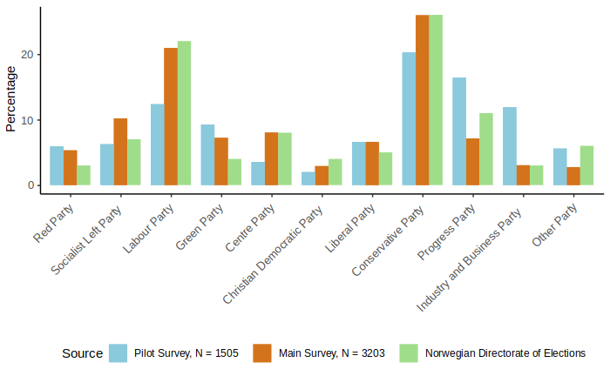
Figure .18: Party affiliations for the pilot and main surveys compared to the Norwegian Directorate of Elections.
Figure Results.19 and Figure Results.20 show the distribution of party affiliations by gender for the pilot and main surveys, respectively.
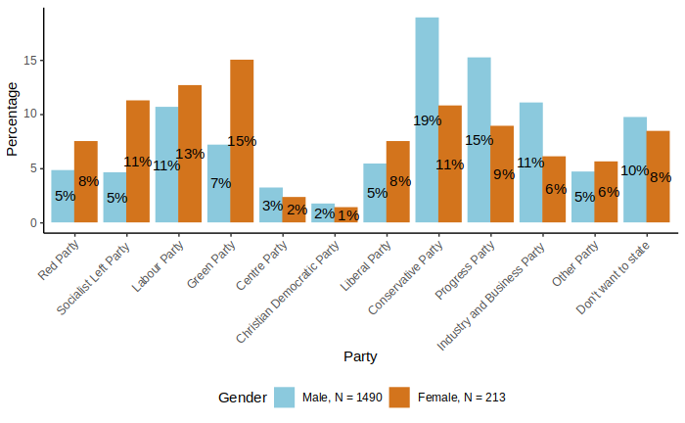
Figure .19: Share of party affiliations by gender, in the pilot survey.

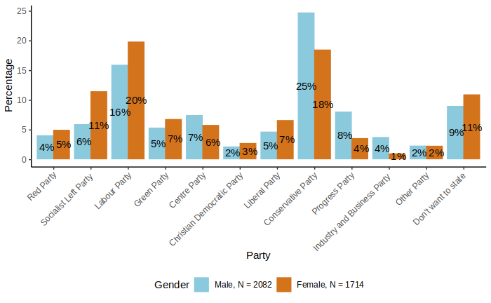
Figure .20: Share of party affiliations by gender, in the main survey.
In some of the following analysis, we will use four main categories for party preferences, based on this question:
- Moderate: Labor Party, Center Party, Christian Democratic Party, Conservative Party
- Environmental: Socialist Left Party, Green Party, Liberal Party
- Populist: Progress Party, Industry and Business Party
- Other: Red Party, other parties, non-voters
This categorization is used because we expect that it could be relevant for explaining attitudes towards transport and environmental policies, but possibly also other political views. We expect those who vote for environmental parties to be more in favor of road pricing and other environmental taxes, and the opposite for those who vote for populist parties. We expect those who vote for moderate parties to be somewhere in between. Note that the moderate and environmental blocs include both left-wing and right-wing parties, while the populist bloc is more right-wing.

Perception of inequality
Figure Results.21 and Figure Results.22 illustrate the responses to questions about economic inequality as shown in Figure Survey design.1 in Section 2.4. Figure Results.21 compares perceived inequality structures for current conditions and ideal conditions based on the main survey. In the main survey, 44% of respondents believe that inequality conditions (“top and bottom”, “pyramid”, “pyramid, fewer at the bottom”) currently describe Norway, while only 14% think these same conditions are how the country should be ideally. Error: Reference source not found shows an equivalent plot for the pilot survey in the Appendix. The results are similar for the pilot survey.

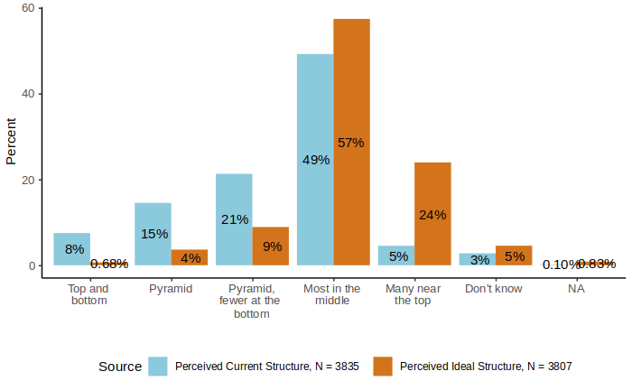
Figure .21: Comparison of perceived current and ideal inequality structures, for the main survey.
In terms of party affiliation, Figure Results.22 shows that main survey respondents in the moderate and environmental party blocs think society is relatively equal, with most people in the middle or a pyramid with fewer people at the bottom. However, those who vote for populist parties and the “other” group are much more likely to think that society is very unequal. When asked how they think society should be, Figure Results.22 shows that the relative differences between party blocs are much smaller. The majority of respondents in all groups think that most people should be in the middle or near the top. The corresponding figure for the pilot survey is included in the Appendix, see Error: Reference source not found.
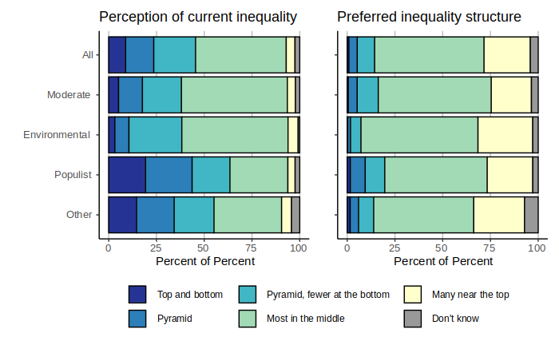
Figure .22: Perception of current inequality and preferred inequality structure, by political party, for the main survey.

Political views and trust in institutions
Figure Results.23 presents the average trust in various institutions for the pilot survey and main survey. The figure shows that respondents from the pilot survey and the main survey tend to have relatively lower trust in politicians compared to other institutions. Respondents’ trust levels for authorities, Norwegian Parliament and the municipal council are similar, with generally higher trust in authorities. Overall, the main survey respondents are slightly more trusting than the pilot survey respondents as the average trust is higher for each institution, except for the municipal council. Figure Results.24 provides a more detailed break-down of trust in various institutions for the main survey. An equivalent figure (Error: Reference source not found) for the pilot survey is provided in the Appendix, although additional institutions are included for the pilot.
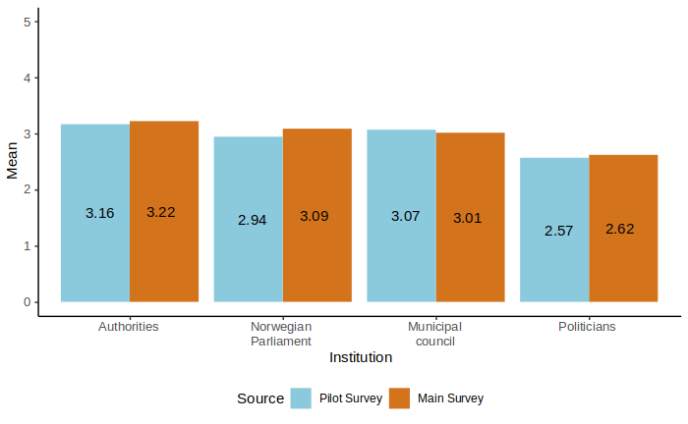
Figure .23: Average trust in institutions (5 = “Full trust”, 1 = “No trust”) for the pilot survey and main survey.
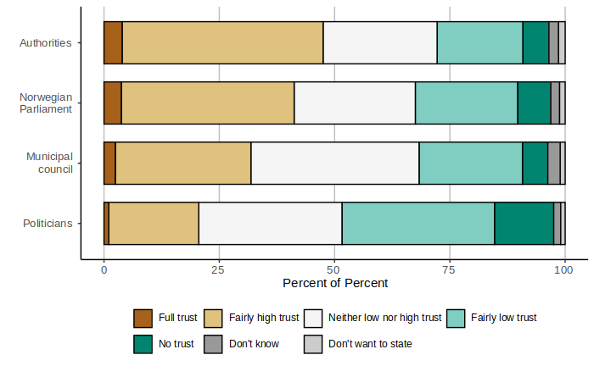
Figure .24: Trust in institutions for the main survey.

Opinions on road pricing and other policies
As discussed in Section 2.4, attitudinal questions are presented differently in the pilot survey compared to the main survey. The main survey contains more attitudinal questions than the pilot survey and the wording of the political statements has been improved. See Error: Reference source not found though Error: Reference source not found in the Appendix for the results on the policy related questions posed in the pilot survey.
Figure Results.25 presents the level of agreement regarding the anticipated effects of replacing current tolls and fuel taxes with road pricing for the main survey.
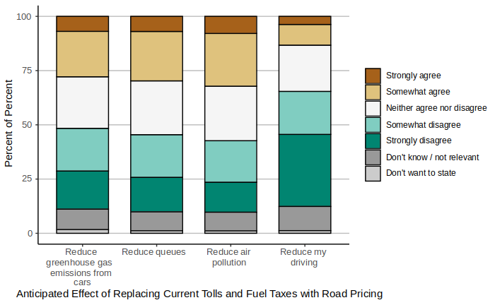
Figure .25: Level of agreement regarding anticipated effects of replacing current tolls and fuel taxes with road pricing, for the main survey.

Figure Results.26 shows the level of agreement regarding various statements based on the main survey. Respondents largely agree about public revenues and air pollution. Furthermore, a substantial percentage are uncertain about the effects of road pricing on privacy.

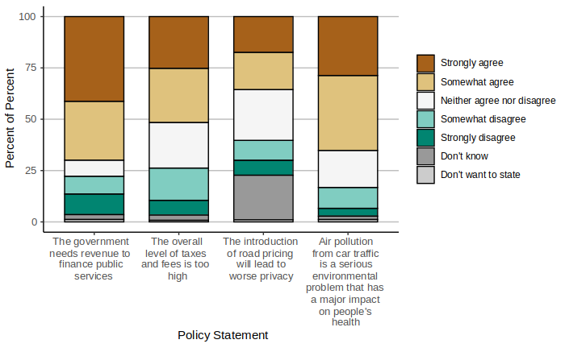
Figure .26: Level of agreement regarding various environmental and transport policy statements, for the main survey.
Figure Results.27 presents attitudes towards which groups will win or lose from road pricing for the main survey. Most respondents believe those with low incomes would lose as a result of road pricing. The responses regarding those with middle incomes and regarding themselves were quite similar, with the majority being “lose some” or “neither win nor lose”. Lastly, respondents indicated that those with high incomes would “win a lot” more often than the other groups. See Error: Reference source not found in the Appendix for a similar figure based on the pilot survey.
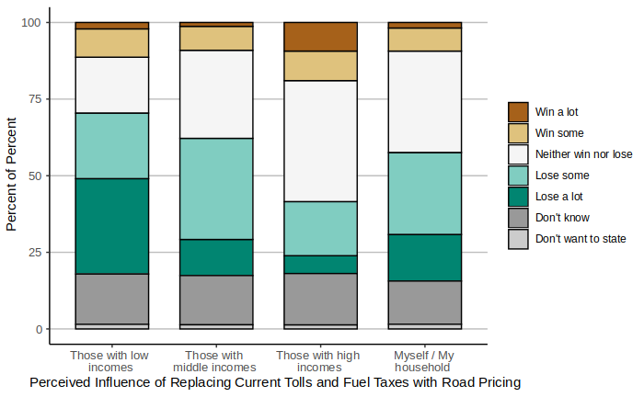
Figure .27: Attitudes towards which groups will win or lose from replacing current tolls and fuel taxes with road pricing, for the main survey.
Figure Results.28 shows that the main survey respondents who vote for moderate and populist parties think that revenues from road pricing should be spent on road investments. Those who vote for environmental parties think that revenue should be spent on investments in public transport, walking and cycling. See Error: Reference source not found in the Appendix for an equivalent figure for the pilot survey.

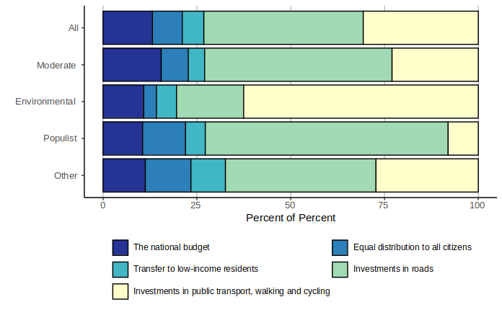
Figure .28: Preferences for how revenues from road pricing should be spent, for the main survey.
Figure Results.29 illustrates the main survey respondents’ views on the road pricing proposal and the current toll system. Respondents report stronger feelings (i.e. very positive or very negative) towards the road pricing proposal, and report more neutral feelings toward the current toll system. Comparing Error: Reference source not found and Figure Results.29, we observe more very negative attitudes towards tolls in the pilot survey (~38% strongly disagree with “It is acceptable to pay tolls”) compared to the main survey (~15% have very negative views towards current toll system).
Figure Results.30 shows attitudes towards proposed road pricing and the current toll system by mode choice, for the main survey. Respondents who use a car are more negative towards road pricing and road tolls. Figure Results.31 describes attitudes towards the proposed road pricing and the current toll system by gender. The share of “very negative” attitudes towards road pricing and road tolls is higher for men. On the other hand, women are less certain about their attitudes as evidenced by the larger share of “don’t know” responses. Figure Results.32 shows attitudes towards the proposed road pricing and road tolls based on education. There are sizable differences in attitudes between education levels. Specifically, respondents with a basic school level are far more negative towards both concepts. This is important considering the basic school level is underrepresented in our sample (3% versus the national average of 23.7%, as shown in Table Results.1. Figure Results.33 presents attitudes towards the proposed road pricing and the current toll system by party bloc. Those in the environmental party bloc are more positive towards road pricing than the current toll system. Nearly 75% of respondents in the populist party bloc are negative towards both concepts.
Figure Results.34 shows the respondents’ attitudes towards the proposed road pricing by reported road toll expense. Respondents who report paying NOK 1-10 or NOK 41-60 in tolls are the most negative towards road pricing, with over 50% of the groups selecting “somewhat” or “very” negative. Figure Results.35 shows the respondents’ attitudes towards the current toll system by reported road toll. Interestingly, several groups have no respondents with very positive attitudes towards the current toll system, in contrast to the proposed road pricing which have some. Respondents who pay NOK 41-60 or more than NOK 100 in tolls are the most negative towards the current toll system. See Error: Reference source not found and Error: Reference source not found in the Appendix for attitudes by income categories, the attitudes are similar between categories.

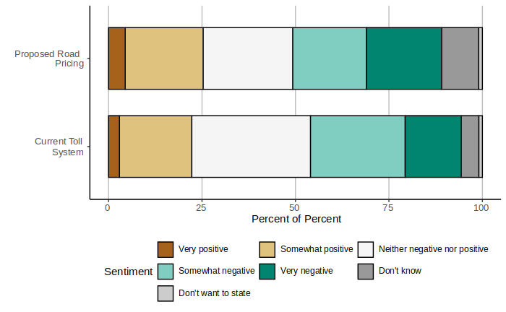
Figure .29: Views on the road pricing proposal and the current toll system, for the main survey.

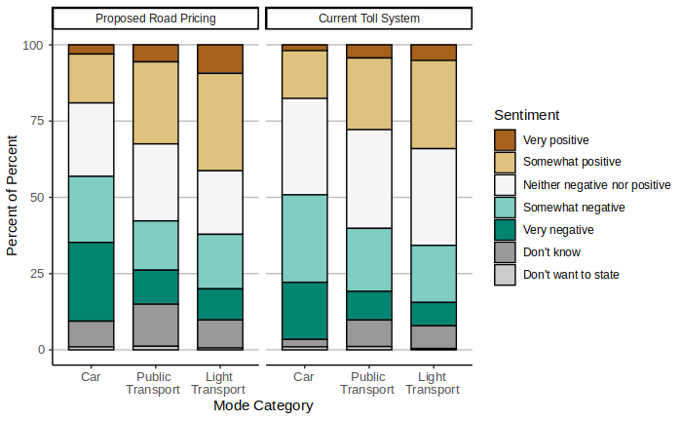
Figure .30: Attitudes towards proposed road pricing and current toll system by mode choice-, for the main survey.

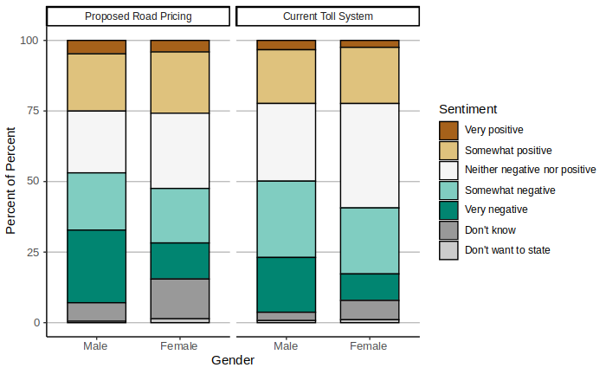
Figure .31: Attitudes towards proposed road pricing and current toll system by gender, for the main survey (Males N = 2082, Females N = 1714).
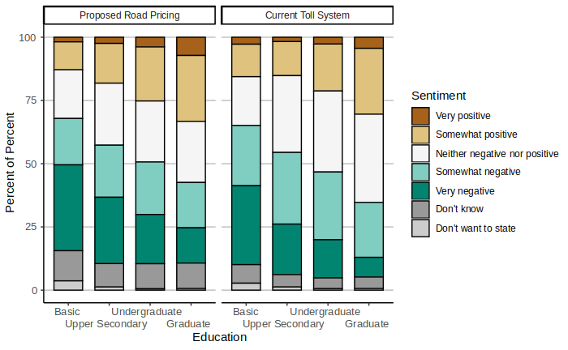
Figure .32: Attitudes towards proposed road pricing and current toll system by education, for the main survey.
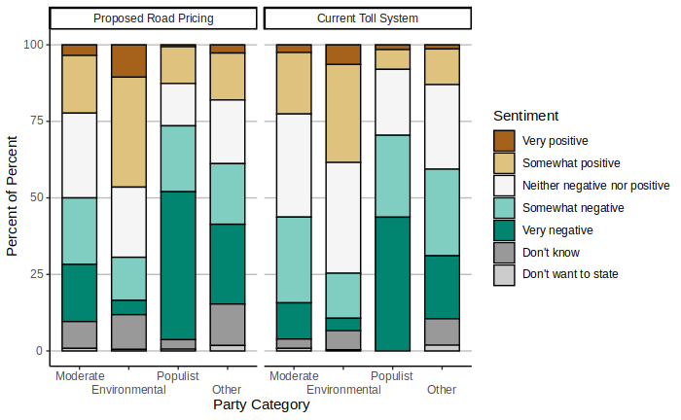
Figure .33: Attitudes towards proposed road pricing and current toll system by party bloc, for the main survey.

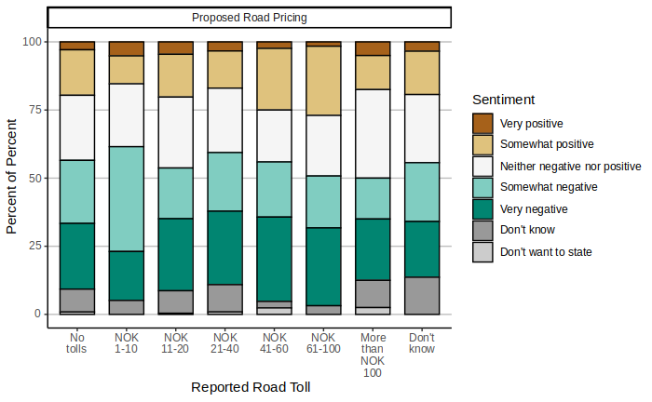
Figure .34: Attitudes towards proposed road pricing by reported road toll, for the main survey.
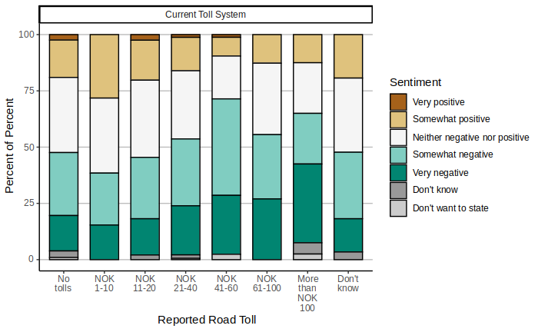
Figure .35: Attitudes towards current toll system by reported road toll, for the main survey.

Conclusion and discussion

Summary of results
In this report, we have documented the survey design and data collection, shown selected results and evaluated the representativeness of the data. In this section we briefly summarize and discuss the findings.
As expected, the main sample, which was recruited using the population register, is more representative than the pilot sample, where respondents were recruited through social media. Interestingly, the samples are similar in a few aspects: for instance, those who have high income and education and vote in elections are overrepresented in both samples, but they are quite different with respect to travel behavior and party support. Compared to the National Travel Survey, the main sample is somewhat overrepresented by public transport travelers, while the pilot survey is overrepresented by private car driving and biking.
Among those who reported voting in the last election, the main sample has a slight over-representation of voters for left-wing and/or environmental parties. The pilot sample is instead more “polarized” as it has an over-representation of voters who support an environmental party and voters who support a party labeled as populist (The Progress Party and the Industry and Business Party). The differences may be partly driven by the fact that there is a large over-representation of men in the pilot survey, but there are also considerable differences in party support between the two samples within each gender.
Regarding travel behavior and access to transport modes, the results are largely as expected. The majority of respondents own or has access to a car. Work trips are mostly done by car, consistent with the National Travel Survey. While survey responses are concentrated in urban areas, there are enough trips occurring in rural areas to constitute a significant proportion of the total trips (around 60% of trips begin or end in a rural area). Roughly half of the respondents in both surveys that travel by car pay tolls on their trip. In addition, according to the road toll calculator, road tolls occur most frequently in more urbanized counties such as Oslo. The main survey respondents tend to report that they pay somewhat more in tolls than what the road toll calculator estimates.
Regarding general political views and attitudes, our results show that about half of respondents think that Norway is a society where most people are on the middle of the distribution. When asked about how society should be, the vast majority want a society where most people are in the middle or near the top. Those who vote for populist parties tend to think that society is more unequal. Concerning trust in institutions, the main survey respondents are more trusting than the pilot survey respondents as the average trust is higher for each institution. Both survey samples tend to have relatively lower trust in politicians and higher trust in other authorities and institutions.
Finally, considering attitudes towards transport policies, our results suggest that opinions on road tolls and road tax reform are quite divided. Many respondents are negative towards both current road tolls and universal road pricing and do not expect the policy to reduce traffic congestion problems, air pollution and greenhouse gas emissions. However, there is also a large group of respondents who are neither positive nor negative, or do not know what their opinion is. Moreover, respondents are slightly more positive towards road pricing than current road tolls. Many respondents would like the revenues from road pricing to be earmarked to either road investments or investments in public transportation, walking and cycling infrastructure, as often found in previous literature.
Attitudes towards road tolls and road pricing vary considerably by gender, education, travel mode and political party. Those with higher education, public transport users and light transport users are more positive towards both policies. Those who vote for the populist party bloc indicate relatively more negative attitudes towards both road pricing and the toll system, compared to the other party blocs.

Discussion
In this section, we discuss the implications of our results concerning the prospects of road tax reform in Norway as well as implications for survey methodology. We also point out some limitations of our study.
The recruitment methods of the pilot survey and main survey were quite different. Since the pilot survey was recruited via Facebook, it was possible for survey respondents to share the survey with their local network, which was not the case for the main survey. We also note that the bicycle mode share for workplace trips for the pilot survey is higher than the national average, which is likely due to the fact that Syklistforeningen (Cyclists’ Association) agreed to share the Facebook post which would attract more frequent cyclists.
As is common with electronically administered surveys, the survey samples underrepresent lower-income and less-educated people, thus there are limits on the generalizability of the results. Our results show that those with low education are also more negative towards road tolls and road pricing. This should be taken into account when interpreting the results, or, if possible, corrected for.
Although the pilot sample seems to be less representative in general, there are also some other interesting differences between the pilot and the main survey. There is a higher share of car drivers and voters for populist parties in the pilot, while these are under-represented in the main survey. This suggests that recruitment via social media could be a useful supplement to other methods, but more knowledge about the representativeness and data quality is needed. In our case, we see that posting on social media also attracts considerable attention from internet users who have strong opinions on the topic. This could have disadvantages in terms of negative attention towards the research.
The results show that many respondents do not expect road pricing to have positive effects, and that it will have undesirable distributional effects. This is in line with previous literature (e.g. Douenne & Fabre, 2022). Notably, the majority of respondents disagree with the concept that road pricing will reduce their own driving more than they disagree with the other anticipated effects. This could be regarded as reasonable, since an increase in road taxes, if not extremely high, will only affect those who have a close substitute to making the trip by car. Trips who are already made by other modes and trips for which there are no good alternatives will not be affected. However, it could also be that respondents underestimate their own opportunities for substitution – particularly in the longer run. Also, road pricing will not result in higher travel costs by car for all respondents, some will pay less.
Our results show that slightly more respondents are positive towards universal road pricing than towards current road tolls. One should note that in these questions, respondents are asked to express their opinion on each policy in isolation, they are not explicitly asked to choose between the two. (In the choice experiment, on the other hand, respondents are forced to choose between introducing road pricing and keeping the current system.) Hence, we should be careful drawing conclusions about the prospects of road tax reform in Norway based on these results.
The fact that current road tolls are quite unpopular is interesting given that about half of car drivers do not pay road tolls on their reported trip today. However, it might be that those who do not pay tolls, pay tolls on other trips or are afraid that they will do so in the future. Interestingly, not all drivers seem to be aware of what they pay in road tolls, which could have implications both for travel behavior and public support (Finkelstein, 2009).
In our results, attitudes towards both road pricing and road tolls vary considerably by gender, education, travel mode and political party. Among car drivers, there is no clear tendency that those who pay high road tolls today are more in favor of replacing road tolls with road pricing. However, these findings are just bivariate correlations, not causal relationships. In future work, one should look more closely into causal explanations of support for or opposition against road pricing, and what this implies for the prospects of a road tax reform receiving the support necessary for implementation.

Further Research
There are many opportunities for subsequent research on this topic, both using the data described in this report and other data and methods. In this report, we have not utilized the data from the choice experiment. The choice experiment data provide a more direct test of support for road tax reform since respondents are explicitly asked to choose between universal road pricing and current policies. It also allows us to test for the effect of key characteristics of the policy (pricing scheme and use of revenues) as well as additional information about the effects of the policy.
Our results suggest that opinions on road pricing and other transport policies are quite divided, with some respondents expressing strong support and some strong opposition. There is probably large heterogeneity also in the preferences for the design of the road pricing scheme (prices and use of revenues), and possibly in the effect of additional information. One method which could be suitable for capturing this kind of heterogeneity is latent class modelling, which allows for a limited number of distinct classes with different preferences. With this method, one could also investigate which factors predict membership of a given class, for instance gender, current car use and party support. Advanced machine learning methods could also prove useful in this respect.
In our survey, respondents state their opinion on a policy that has not been introduced, and that they do not have any experience with. Even if our data allows us to test for the effect of additional information, we can only evaluate the effect within the context of a one-shot survey. Conducting field experiments with repeated surveys would allow us to study experiences with pricing incentives or the effect of information about prices. The drawback of field experiments, on the other hand, is that they are often of a limited scale and participants do not experience the full consequences of the policy. Ideally, one would like to run a full-scale pilot of road pricing in one or several cities, which would make it possible to both experience and evaluate the effect on traffic and congestion, and on public opinion.
Finally, we recommend more research on survey methodology, particularly related to support for road taxes and other environmental taxes. To evaluate the prospects of such taxes being successfully implemented, representative data on public opinion is key. We demonstrate that road taxation is a topic that receives considerable attention on social media, which can also be exploited to recruit a substantial number of respondents at a low cost. Whether this is a fruitful way forward for survey methodology is however an open question.

References
Baranzini, A., Carattini, S., & Tesauro, L. (2021). Designing effective and acceptable road pricing schemes: evidence from the Geneva congestion charge. Environmental and Resource Economics, 79(3), 417-482.
Börjesson, M., Asplund, D., & Hamilton, C. (2023). Optimal kilometre tax for electric vehicles. Transport Policy.
Börjesson, M., Eliasson, J., Hugosson, M. B., & Brundell-Freij, K. (2012). The Stockholm congestion charges—5 years on. Effects, acceptability and lessons learnt. Transport Policy, 20, 1-12.
De Borger, B., & Proost, S. (2012). A political economy model of road pricing. Journal of Urban Economics, 71(1), 79-92.
Douenne, T., & Fabre, A. (2022). Yellow vests, pessimistic beliefs, and carbon tax aversion. American Economic Journal: Economic Policy, 14(1), 81-110.
Finkelstein, A. (2009). E-ztax: Tax salience and tax rates. The Quarterly Journal of Economics, 124(3), 969-1010.
ITF (2023), Decarbonisation and the Pricing of Road Transport: Summary and Conclusions. ITF Roundtable Reports, No. 191, OECD Publishing, Paris.
Skatteetaten & Statens vegvesen (2022). KVU Veibruksavgift og bompenger. Konseptvalgutredning Trinn 1 – versjon 1.0. 15.november 2022
Sælen, H., & Kallbekken, S. (2011). A choice experiment on fuel taxation and earmarking in Norway. Ecological Economics, 70(11), 2181-2190.
Tatham, M., & Peters, Y. (2022). Fueling opposition? Yellow vests, urban elites, and fuel taxation. Journal of European Public Policy, 1-25.
Aasen, M., & Sælen, H. (2022). Right-wing populism and climate policies: Explaining opposition to road tolls in Norway. Transportation Research Part D: Transport and Environment, 105, 103222.

In the case of Norway, a pre-requisite was that road toll revenues should still be earmarked to road toll projects, even if the tolls are collected through the road pricing system. In our survey, we abstract from this and consider all revenues the same but explore public preferences for how the revenues should be used.
https://www.toi.no/aplanet/
In the Madrid version respondents were not asked about the location of the destination.
A sponsored Facebook post means that an organization (in this case, the Institute of Transport Economics) pays Facebook to display its post in the newsfeed of a certain number of users, also users that do not actively follow the organization. Users may be selected based on certain criteria. In our case, we targeted Facebook users in Norway.
It is noted that one respondent in the main survey indicated they were born in 1901, which is highly unlikely. However, the respondent’s other responses were reasonable, therefore we did not remove them from the sample.
In the survey, respondents are defined as employed if they report this as their main activity. (Those who combine education and part-time employment were instructed to report “Student”.) In official statistics, individuals are defined as employed if employment is one of their activities, also if they have other activities like education of receiving benefits.
Although the term used in the question was “planning” and not “considering”, it might be that respondents ticked several alternatives if they were planning to buy a car and were considering several options in terms of the type of car.
The electric share of new passenger cars in Norway sold in January-September 2024 is 88%. We do not have statistics on the electric share of used cars transactions, but the electric share of the entire passenger car fleet was 24% in 2023.
“The 10 largest cities, towns and municipalities in Norway”, Statistics Norway, December 2023. https://www.ssb.no/befolkning/folketall/artikler/de-storste-byene-og-tettstedene-i-norge
As similar scheme was evaluated in the government study on road tax reform (Skatteetaten & Statens vegvesen, 2022). This study also included another alternative with three categories of areas: Major urban areas, other urban areas and rural areas.
There are a small number of trips that are not shown on the maps since they lie far outside the municipality boundaries. For example, points in Svalbard are not shown.
This implies that the definition of rush hour is subjective.
The drawback of this approach is that we exclude respondents who have zero calculated tolls but report positive tolls, but not those who have positive calculated tolls but report zero tolls. This implies that we exclude some respondents who over-report but no respondents who under-report their road tolls.
In Norway, all local elections take place at the same time every fourth year, two years after the national election.
One notable example is The People’s Action No to More Road Tolls, which received considerable support in some municipalities in the local election in 2019. However, this party only received 0,2% of the votes in 2023.
The Industry and Business Party was a new party in the 2023 election, and it is not obvious where to place it on the left-right scale. The party describes itself as centrist, but typically argues for lower taxes.
Since the two populist parties included here typically do not attack the economic elites in their rhetoric, one might suspect that the respondents perhaps did not consider economic inequality in a narrow sense when answering this question, but rather inequality and elitism more generally.
This means that for instance the price level in rush hour in urban areas could have a positive effect on support in one class, but a negative effect in another class.

